Capstone Project

IRONWORKS

Men’s Grooming & Supply Co.

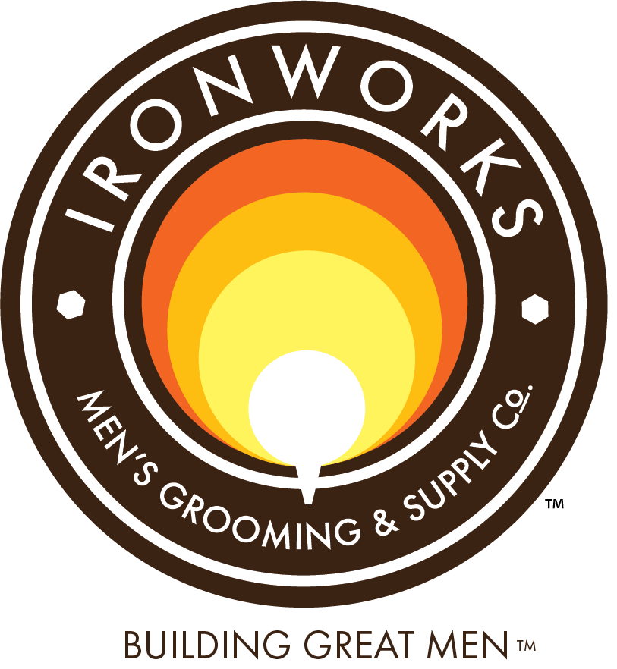

February 5, 2020

Eliot Cleveland, MBA Candidate

Dr Jeff Harrison, Faculty Advisor

Table of Contents

**Executive Summary** 2

**Introduction to Ironworks** 2

**Scope of Project** 3

**Industry Research** 4

**Insights** 4

**Market Research** 5

**Insights** 6

**Sales Data Analysis** 6

**Insights** 7

**SWOT Analysis** 8

**Insights** 10

**Internal Analysis – VRIO** 10

**External Analysis - PESTLE** 11

**Recommendations** 13

**Build a Change Management Program** 13

**Other Recommendations** 15

**Future Capstone Recommendations** 16

**Conclusion – Retail Strategy** 17

**Bibliography** 18

**Appendix** 19

Figure 1 – Retail and Service Sales, since June 2017 20

Figure 2 – Monthly Sales Breakdown 21

Figure 3 – Service Sales by Stylist 22

Figure 4 – Product Sales: Past 12 Months 23

Figure 5 – Cigar Sales 24

Figure 6 – Retail Sales by Category, since June 2017 25

Figure 7 – Top 15 Retail Sales, 2019 26

Figure 8 – SWOT Analysis Matrix 27

# **Executive Summary**

This capstone project is a final report outlining the research, analysis, insights and recommendations for Ironworks Men’s Grooming and Supply Co. Research began by examining the men’s hair salon industry as a whole, then looking at regional and local markets in order to understand various success factors for Ironworks. This provided a context for analyzing the sales data. A series of strategic frameworks were applied to inform internal and external challenges. Recommendations are given to increase retail sales, inform future decisions and capstone projects, followed by an extensive appendix of further analyses.

# **Introduction to Ironworks**

Ironworks’ underlying mission is “building great men” through an array of services and products it provides. Located in Short Pump, Virginia, Ironworks is a luxury men’s hair salon that has served the Greater Richmond area for the last four years. Through careful planning and execution of its owner, Ironworks has developed into a strong brand and has steadily grown and maintained profitability over the brief period since its inception.

Ironworks is known locally for its high-quality haircuts and beard trims. Each haircut includes a professional consultation, styling and a local craft beer. Customers may also upgrade their experience to a tighter cut, hot towel treatment or a straight razor shave. Other services include hair coloring, massage, shoe shines and restorations, group events and women’s haircuts. Ironworks also offers a retail selection of premium hair and beard care products, Ironworks branded shaving products, tee shirts, and the recent addition of cigars.

As part of my research, I made it a point to experience the service at Ironworks. Perhaps like many economically challenged students working through grad school, I was skeptical that it would be worth the premium price. I booked an appointment for a basic “Busy Man” haircut. I soon realized that Ironworks is a truly unique business.

From the outside, it has the appearance of a traditional barber shop. However, as you step inside you start to realize that it is something special. A designated host, not a barber, greets you as you walk in. The expert stylists are busy executing their skillset, undistracted by your arrival and keeping on schedule.

The décor is understated, industrial and authentic. The store is outfitted with well-maintained top-of-the-line fixtures and kept immaculately clean, yet it is approachable. Ironworks has a calm vibe, complete with local craft beer and premium cigars. Ironworks may be for men but it manages it in a way that is a sharp contrast to the loud Buffalo Wild Wings-like ambiance of Sport Clips. Ironworks is more than just a dressed up Great Clips with ten TVs. It only has one TV and yet so much more.

# **Scope of Project**

The original focus of this analysis was on retail strategy with a secondary goal of exploring future growth options. Retail sales are a significant portion of revenue at Ironworks and a way to boost marginal income and profitability without expanding the location or significantly increasing investment in human capital. The original objective of the project is copied below.

“A fully developed retail strategy is an immediate need for Ironworks and will be the primary goal of this project. Until now, focus has been primarily on the service side of the business. As Ironworks nears its service capacity, retail has remained relatively unexploited. Scholarly research and market analysis will inform a customer profile and recommend specific business parameters, metrics and techniques regarding the retail strategy.

Recommendations will also explore the viability and future outcomes of up to four potential decisions described by the client, including opening another location, further revenue maximization at the existing location, an employee ownership program, or selling the business outright.

This project is bounded by the stated goal of reducing debt service to zero in 3.5 years. With this is mind, retail strategy recommendations will be self-funded by current operating profits. Growth decision strategies will build toward the 3.5 year time horizon. Recommendations will in good faith maintain the Ironworks brand, add customer value, and highlight ways to increase marginal sales growth. The goal of this project is to provide useful data and information to Ironworks to utilize in future decisions regarding the topics outlined in this section.”

Initial analysis focused on sales data and looking at ways to better understand the industry, the market, and analyze Ironworks’ product movement and sales techniques as a means to increase retail merchandise sales. A set of retail recommendations are proposed herein. However, it was evident early on that retail sales already far exceeded industry averages. Dramatic ways to increase sales without diluting the Ironworks brand weren’t obvious.

Ultimately, the latter part of the research, analysis and recommendations focused on understanding what makes Ironworks such a success, its intangible value, and recommending future capstone projects for this fast-growing company.

# **Industry Research**

Ironworks is unique because it’s not exactly a barber shop or a hair salon. It lies somewhere in between the two. Since there is no NAICS code for men’s hair salons, industry research synthesized the relevant points from both industries. The two industries have some obvious similarities but are quite different in some key ways.

Barber shops cater almost exclusively to men while hair salons are patronized primarily by women. Hair salons tend to charge more and differentiate on quality while barber shops tend to compete on price and convenience. Other services such as hair coloring and treatment, facial and nail care, and retail sales are significant portions of revenue at hair salons (over 40%).[1] Conversely, barber shops generate 92% of revenue from haircuts, grooming and styling alone.[2]

One surprising statistic is the sheer magnitude of size difference between the two industries. There are about six times as many businesses operating as hair salons generating about twelve times the revenue vs barber shops. Yet in terms of employment structure and competitive landscape, the two industries are very similar with 90% of hair salons and 97% of barbershop businesses listed as non-employers. There are very few large companies in either industry.

According to IBISWorld, one reason for this disparity in magnitude is that “Barber shops experience high levels of external competition.” Only 44.0% of men use barbershops, 25% get haircuts from friends, family or cut their own hair, and the rest patronize salons.[3]

Another key difference between the two industries is the market segmentation, specifically by age. While customers 34 and under represent the smallest segments of both industries, customers in this age group generate over 7% more industrywide for hair salons (24.6% vs 17.4%), indicating that younger hair salon patrons may be a more captive audience. Both industries tend to see higher percentage contributions from age groups 35 and older due to higher levels of disposable income and greater priority on grooming placed in these age groups.[4]

## **Insights**

Ironworks is a true men’s hair salon in that it resembles both industries. In terms of primary service revenue and other services, it is very much a barber shop. Although it is equipped and does offer other services, over 98% of service revenue is drawn primarily from haircuts and men’s grooming, comparable to 97% across the industry.[5] Because Ironworks has the equipment to provide other styling services such as coloring, it is likely that Ironworks captures some male customers who would otherwise patronize a traditional hair salon. On the surface, this equipment provides a point of differentiation and potential but nevertheless is underutilized in comparison to traditional hair salons

However, retail merchandise sales fall more in line with traditional hair salons. At Ironworks, an average 6.8% of revenue comes from retail merchandise sales (since 2017). This is more than double the barbershop industry retail sales average of 2.7% of total revenue.[6] Ironworks’ retail sales peaked at 7.7% in 2018 much closer to the traditional hair salon industry average of 9.5%.[7]

# **Market Research**

**Regional Markets**

Distribution of establishments generally follows population centers however Virginia has an above average concentration of both barber shops and hair salons. Virginia houses 2.6% of the US population[8] yet operates 3.3% of the total number of US barber shops and 3.1% of US hair salons.[9] This amounts to 26.9% and 19.2% more establishments per capita than the national average.

**Local Competitive Landscape**

There are a few competitors offering premium haircuts in different regions of Richmond. Cutz for Guys operates in Chesterfield County and Ace of Blades is in Downtown Richmond.[10] Because of the geographic divide, it is unlikely that these other men’s salons compete directly for customers. Closer in proximity, nine barber shops compete within the Short Pump area. Six of those including Ironworks are independent; the remaining three are franchises.[11]

**A Growing Niche**

In addition to the independent firms named above, four of the top ten men’s hair salons in Richmond are Sports Clips locations[12], a franchise that offers some other services and caters specifically to men. Sport Clips is one of the few major players in the industry capturing 0.8% market share in company owned stores and 19.3% market share including all franchises.[13]

**Local Demographics**

Bizminer reports that the median age in Short Pump is 39 years with 48% of households earning greater than $100K per year. The US national median age for men is 38[14] and only 30% of households earning greater than $100K per year.[15]

## **Insights**

All things considered, there is growing niche for men’s hair salons in the Richmond area and Virginians have an above average demand for hair care. Short Pump residents are slightly older at the median and may have more disposable income than the national average. This suggests the local residents have the desire and the means for quality hair care. Resources and capabilities aside, this likely explains another factor of Ironworks’ acute success and that of similar businesses.

# **Sales Data Analysis**

**Historical Sales**

The available dataset spanned just over 27 months from June 2017 through September 2019. Both service sales and retail sales averaged a monthly growth rate of about three percent, more than doubling average monthly sales over that time period, though not in tandem (Figure 1). Service sales increased relatively evenly over that time period. However, on a percentage basis, retail sales sharply increased in 2018 then slowly declined to the present, see below.

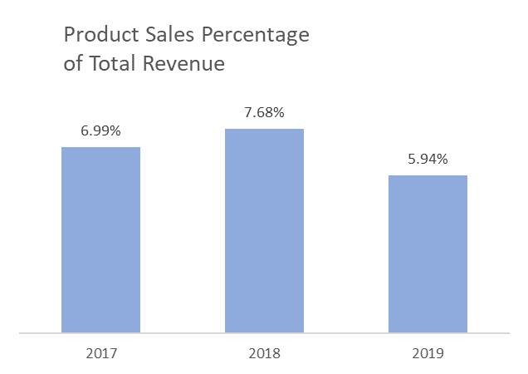The reduction in product sales, in real and relative terms indicates a priority shift away from retail towards the service side of the business, beginning in the summer of 2018. The owner explained that this was likely because there were two stylists working at that time who actively focused on sales. Their departure coupled with the very real need to meet service demand meant declining merchandise sales. A table of actual sales and running growth rates over time can be found in the appendix (Figure 2).

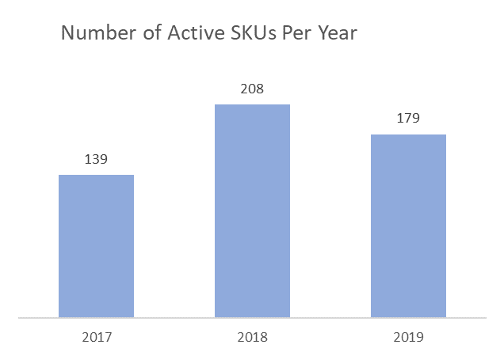**Does more variety lead to greater sales?** Some evidence suggests retail sales may be linked to the number of active SKUs in the sales record. The comparison chart below shows the total number of active SKUs follows the pattern of retail sales. However, in our initial capstone meeting, the owner discussed winnowing away the slow-moving products and only restocking the more popular products. Injecting variety ties up a lot of capital. Any additional revenue isn’t necessarily realized because a lot sits around in inventory. For that reason, he tends to spend a lot of effort researching each new product before deciding whether or not to launch it.

**Are Declining Retail Sales a Cause for Alarm?** Retail sales have been in slow decline for the past 14 months. Efforts have shifted towards meeting the service demand and stretched the capacity of its staff. Each of the team of four stylists are more efficient than ever. They each generate $7-9k in service revenue every month depending on the skill level/tier of service (Figure 3). On one hand, business is booming and the staff is doing well to keep pace, but it is concerning that retail sales have dropped despite gaining so many new customers.

**Recent Sales**

Retail sales strategies have changed in some major ways in the past twelve months of the data. To some extent the past 12 months of sales data represent the new normal at Ironworks. Cigars were introduced in late 2018. Hair care and grooming offerings have been deliberately winnowed down to 3 main brands, see below. Out of 179 active SKUs in 2019, the top 15 items by revenue represent 62% of total retail sales.

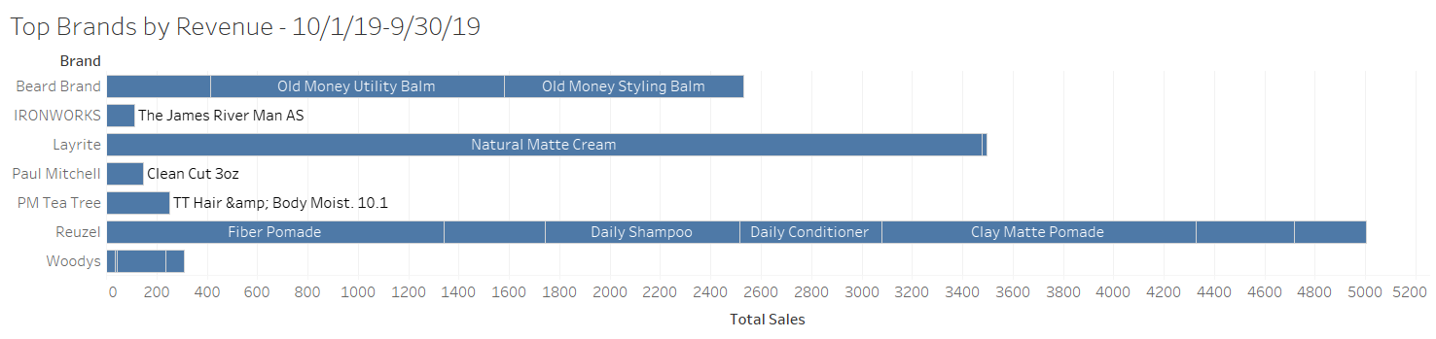

## **Insights**

**Possible out of stocks?** There is some evidence that there may be occasional out of stocks on various products. Across the top 15 items by revenue there are 12 examples of months in which no sales were recorded for specific products (Figure 4). Orders are placed regularly. On my visit, I asked the front desk staff what product he would recommend and he recommended something that was out of stock. The cigar sales are a much shorter dataset but they also appeared very sporadic (Figure 5). The owner confirmed that was “100% supply related” because they were researching potential offerings before re-ordering.

**Low sales environment** is evident. There was no talk of hair products while I was getting my haircut. There is sort of a stern anti-salon man vibe going on. They were total professionals and surely would have answered any questions but nothing was forthcoming. Added to the categorical evidence of more aggressive sales tactics in 2018/early 2019 (Figures 1 & 6), it’s safe to say the sales culture has changed. Service revenue however has risen around 15% over the past year.

**Retail sales compliment services provided**. The main sellers are what is stocked in the back bar. Top selling items are pomades, beard balms and other hair care (Figure 7).

# **SWOT Analysis**

Strengths

**Differentiated Service**

Ironworks’ skilled staff meticulously completes each haircut with the efficiency and timing of the Japanese rail station. The tiered pricing offers clients a range of options tailored to each customer. A 30-minute haircut starts on time and lasts the whole time. At Ironworks you get what you pay for and clients are willing to pay more for a top-notch experience.

**Brand**

Ironworks’ brand is closely guarded by its founder. Mark Ludovico has painstakingly built a man’s oasis within the walls of Ironworks. The name of the business has local relevance and evokes the minimalist industrial décor of the salon. Each service includes a local craft beer. The atmosphere is free from mindless banter or pushy sales techniques. There may be a game on the single TV by the door but the sound is turned down with contemporary music in the background. Nothing distracts from the quality of service.

**Retail Sales**

Ironworks bills itself as a supply company and has remarkable retail sales despite the unspoken policy of low-pressure sales techniques. An above average percentage of revenue comes from retail merchandise sales suggesting customers are willing to pair premium products with their service. Offerings range from traditional men’s hair care products to gift items and cigars.

Weaknesses

**Capacity**

Ironworks occupies a small footprint. It’s four full-time stylists stay fully booked. Although it has six chairs, it felt cozy with four clients and four stylists in the same space. The waiting area has space for 5-6 people with a small amount of space reserved for retail items. 100% capacity would push the limits of the waiting area and might feel crowded during peak service.

**Sales Technique**

The stylists appear to be the driving force of retail sales however, each stylist takes a unique approach if any to suggesting hair care products. Their focus is on the service and retaining customers and less so on conventional retail sales suggestions.

Opportunities

**Social Media Presence**

Ironworks is modestly represented on social media. The company posts monthly photos on Facebook/Instagram and less frequently on Twitter. Its clients rave about the service and offer fun, positive and sincere reviews. It seems that frequency and regularity of original company posts are an untapped resource.

**Expansion**

Ironworks is limited by its capacity. Its tenured stylists are fully booked. Two new stylists have recently been hired. Although their contributions have not yet been realized, if they work out, Ironworks will max out its capacity for growth. Expansion options could include a build out of the current facility or building a second location.

Threats

**Competition**

For now, Ironworks offers differentiated services but there is more demand than it can handle. The threat of a new market entrant offering similar products nearby seems likely. Barriers to entry include some licensing and capital but are not insurmountable.

**Local Market Forces**

Short Pump remains a prosperous suburb of Richmond. As the region continues to grow, costs may rise and traffic congestion may increase. Right now, it sits in an ideal location but the population and commercial center seems to shift increasingly westward. Some things like cost increases may be slow and predictable while others less so as other retail industries continue to face an existential crisis.

## **Insights**

Capacity is a major concern. Ironworks’ service threshold has yet to be tested but that day seems imminent. At the beginning of this project, my personal experience trying to book a haircut showed a minimum 24 hour wait for the first available stylist, longer during peak hours. This was tested at three later dates including once after a fifth stylist was hired. Getting a same day booking during peak hours seems impossible. This suggests more demand than Ironworks can currently accommodate. It could also indicate the likelihood of a new competitive entrant.

The need to hasten future expansion plans may be the most significant insight from the SWOT analysis. There are other priorities highlighted above that could help drive marginal profits and mitigate some risk during an expansion. Ironworks has a winning formula that people clearly want. A SWOT matrix is included in the Appendix (Figure 8).

# **Internal Analysis – VRIO**

**Stylists**

No doubt, Ironworks has expert stylists but every shop has at least one great barber. Having a team of excellent barbers is tough but not impossible. However, Ironworks staff is organized to exploit because they foster a learning environment which encourages teamwork. The apprentices quickly learn expert skills and absorb the teaching methods and team mentality.

**Brand**

Ironworks’ brand and reputation is certainly recognized locally, however it has yet to prove itself in an expansion scenario. Its brand strength lies in its core service reputation but doesn’t necessarily extend to other products and services, currently.

**Industry Knowledge**

This one checks all the boxes because of the hard work, research and lessons learned along the way to creating a successful business in this particular market. The formula seems difficult to imitate. It also manages a respectable retail side indicating strong product knowledge as well. Ironworks generally has survived and thrived in the high-end retail environment of Short Pump.

**Customer Experience**

Ironworks is a differentiated brand but currently has no means to exploit this strength beyond its capacity. The ability to expand and exploit this resource relies heavily on having network of skilled staff that can see through a growth period without diluting the service level or brand.

**Beard Specialists**

Ironworks particular knowledge and reputation for beard trims is certainly all of the first three categories. This skillset is particularly exploitable as beards are particularly in vogue.

|  |  |  |  |  |
| --- | --- | --- | --- | --- |
| Resource/Capability | Valuable | Rare | Inimitable | Organized to exploit |
| Stylists | Yes | Yes | No | Yes |
| Brand | Yes | Yes | Yes | No |
| Industry Knowledge | Yes | Yes | Yes | Yes |
| Customer Experience | Yes | Yes | Yes | No |
| Beard Specialists | Yes | Yes | Yes | Yes |

# **External Analysis - PESTLE**

**Political**

Haircare on its own is apolitical. Messaging of the business focuses on core business and appeals to all. For sure, Ironworks walks a fine line with male-centric messaging, cigar and beer sales. To some, this might invite minor concern, but these things also sort of define the brand and do not seem to detract from Ironworks’ reputation for quality haircuts and beard trims.

**Economic**

As a luxury men’s salon, Ironworks may be slightly more susceptible to losing business during a down economy. Male customers may increase time between haircuts, forego non-essential products and services if the economy stumbles. Industry growth in traditional barber shops is tied to population distribution and growth. Both population and disposable income are expected to grow slowly, around 1% at the national level.[16] Ironworks is situated in a convenient location for many prosperous Short Pump residents.

**Social**

Ironworks market frame is male specific by design. This falls in line with the barber shop industry but Ironworks reaches a premium salon feel. Ironworks is the top result when using the search terms “Men’s Hair Salon” in the Richmond area and also the highest rated on Yelp.com with 70 reviews (accessed 12/16/19). Although the business is flourishing, there is room to grow in terms of content on social media. Beards continue to remain popular. There is a functional need for quality beard trims, a core aspect of its business, but it is yet to be seen how far the trend will sustain over time.

**Technological**

Ironworks makes good use of enterprise software to manage its bookings, inventory and sales. This allows for smooth operations, less missed appointments, more consistent sales and robust data reporting. There have been some successes boosting retail awareness and sales. Perhaps more can be done with the system to gather information about shopping preference through 1-click surveys or through more deliberate sales campaigns. One trend in the industry is online check-in but this is not in place at Ironworks, currently.

**Legal**

Licensing is a factor in the industry as most barber shop or salon operators are required to have some training or certification. The ABC license adds another degree of complexity but differentiates it from most of the competition. Talks of expanding to include a smoking room invite new questions about smoking laws and ABC laws should beer sales increase as a result. Broadening its liquor license to include more beer sales may be a source of additional income.

**Environmental**

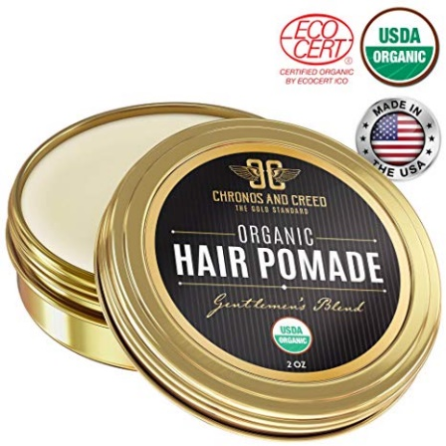As a small business, Ironworks doesn’t have much of a carbon footprint to speak of on its own. Efficient equipment, lighting, practices and waste reduction will pay dividends over time and as the business grows. There is a general move and preference for eco-friendly practices and organic products which IBISWorld suggests in the following passage.

“Organic, natural and ecofriendly products are expected to become more prominent over the five years to 2023. Environmental concerns are forecast to become more prevalent in the years ahead, which will lead … to evolving consumer preferences toward a more sustainable lifestyle. Salons will also attempt to keep water waste to a minimum. Furthermore, operators will stock professional grade, environmentally friendly resale merchandise; these high-margin items will provide the consumer with salon-quality results at home.”[17]

It is not clear how pervasive this is in men’s hair care but there are some intriguing retail options out there. IBISWorld indicates a “paradigm shift in male attitudes toward grooming and self-care,” noting an annual 7.8% increase in the sale of men’s beauty products from ‘09-14. [18]

# **Recommendations**

In the competitive environment of Short Pump, Ironworks is by most accounts a success story. Its business has grown at a steady even pace since its inception, continues to service its debt, and will soon meet its service capacity. Despite this success and having more new customers and foot traffic every month, it has struggled to boost retail sales over the past year. There have been some changes in sales approach to the retail side as Ironworks finds its way as a supply company.

Some changes were deliberate such as the introduction of cigars, which adds intrinsic value to the brand but has yet to generate substantial profits. Other changes have happened unintentionally like the loss of two strong salespersons, perhaps resulting in a shift to only moving a handful of products.

Ironworks is succeeding as a barber shop but starting to drift as a retail store. Three topics of recommendations are prescribed below: Build a change management program to align retail success with service excellence, a list of other recommendations regarding operational needs, product offerings and marketing, and recommendations for future capstone projects.

## **Build a Change Management Program**

Although Ironworks is a relatively small enterprise with less than 10 employees, it is evident that change efforts may be similarly challenging to implement as any other organization. This is in part due to un-hierarchal organizational structure and lack of an embedded manager. Even though it is a small company, its employees feel they contribute uniquely and have each contributed in very tangible ways to Ironworks’ success.

Given Ironworks’ success, it’s understandable that the staff may be less inclined to earnestly accept shortcomings and see the need to implement real strategic change. Staff buy-in is needed if Ironworks is to secure its foothold on retail sales and develop its reputation as a supply company. Using John Kotter’s framework for change management[19], a brief outline of how the process might look is described below.

**Step 1: Create a Sense of Urgency**

Comparing revenue from August ’18 versus August ’19, product sales for the month were 36% lower in 2019 yet services were 30% higher when comparing the same two months. Put another way, for the months of July ’18 through February ’19, retail sales never dropped below $2k, however, for March – September ’19, retail sales only exceeded $2k in one out of seven months (Figure 2). Clearly there has been a culture shift away from product sales but the staff may not be aware of how dramatically lower retail sales have slipped.

**Step 2: Build a Guiding Coalition**

The staff will hopefully agree that retail sales play an integral role in the success and vision of Ironworks. Introduce these concerns and seek input about creative ways to increase sales without tarnishing the brand or inhibiting service revenue or return clients. This step is about planting a seed, getting buy-in, and seeing who the first followers might be.

**Step 3: Form a Strategic Vision and Initiatives**

Once some of the staff is on board and providing input, this is where the specifics of the program are formed. This is not about being a good stylist or making a living. It is about taking Ironworks’ retail to the next level.

*How will sales be tracked and tied to each stylist*? Booker hopefully has this functionality or at least the ability to tag a searchable comment field attributing the sale to its stylist.

*How to ensure sales efforts are consistent and align with Ironworks’ vision?* This is something that will require the team’s input. Perhaps a script or framework or more training in sales is necessary. Inventory and ordering processes will need to be formalized to make Ironworks retail offerings as exceptional as its staff.

*What messaging do we want to convey to the customers?* Each time a customer is engaged is an opportunity to tell Ironworks’ story and get valuable feedback about how to improve offerings.

*How much is enough?* There needs to be a long-term goal for sales that is aggressive but attainable. For Ironworks, this should align with the US hair salon industry average of about 10% of service revenue.

**Step 4: Enlist a Volunteer Army**

Some of the staff will be more apt to take on the challenge of increasing retail sales. Lean on those staff that are bought in to spur initial changes, monitor success, and recommend changes.

**Step 5: Enable Action by Removing Barriers**

This step could take a few forms. If product knowledge, language or sales technique are issues, then allow time to learn. If price is an issue, perhaps some pricing latitude like first time buyer discount or price matching could be built in to grease the wheels. It’s important to get the stylists talking about the products and comfortable with suggesting them.

**Step 6: Generate Short Term Wins**

No victory is too small. Celebrate when monthly sales exceed $2k or go up a percentage point of service revenue. Reward top performers with a commendation such as salesman of the month, a gift card, dinner, or by spotlighting them at Ironworks Night. Talk about how they are helping to build a better Ironworks by elevating its credibility as a retail store and providing funds to invest in fresh products and expand the company.

**Step 7: Sustain Acceleration**

Don’t let up. Re-examine sales goals and effectiveness of strategy. Adjust the plan if needed. Continue to seek input from staff and keep going until the staff is 100% on board. Build great salesmen.

**Step 8: Institute Change**

By now there should be a fully formed plan and noticeable gains in retail sales. Make the plan official and hold staff accountable to expectations. Once new practices overtake old habits, sustained sales will come easier and new staff will pick up the techniques quickly as Ironworks continues to grow.

## **Other Recommendations**

**Inventory management** will be essential to keeping a healthy retail business. Lagging products or brands should be regularly assessed and liquidated if necessary. This should be balanced with a strong effort to consistently stock fast-moving items and introduce new complimentary products as well. Out-of-stocks should be kept to a minimum

**Salesmanship** will be critical to Ironworks securing its place as a retailer. This will rely on both the quality of selection and skill of the staff at matching products to client needs. The stylists are proven talents at finding the perfect cut for every customer. In theory, the same can be done on the retail side but it will take a change in attitudes about sales and a realistic assessment of priorities based on business need.

**Promote** **eco-friendly** messaging. Research water based and organic hair and grooming products. Millennials are starting to age into the core 35-44 years segment. They tend to be more earth conscious than older generations and will soon be the primary audience.

**Build** **cigar sales**. Early performance is encouraging. One cigar SKU came in at #5 on the top sellers by quantity for the year (Figure 7). As this category grows, consider providing a menu with tasting notes of each cigar or selling Ironworks branded Zippos or torch lighters.

**Liquidate** dormant inventory outside of Ironworks through online platforms such as Amazon, Facebook Marketplace, or consignment sales. Much of the inventory is sunk cost and should eventually be written off to make room for new investments.

**Alcohol sales** are a potential source of retail revenue. Look at requirements for an ABC-off license to sell Ironworks branded growlers to go.

**Promote retail content** on social media. Currently, most online content focuses on the service business. Reward followers for liking, sharing, or tagging Ironworks. Continue to build a large network on various platforms. Market to women seeking to buy something nice for their partner.

## **Future Capstone Recommendations**

**Growth Strategies**

Although some aspects of business performance and the need for expansion were addressed briefly, an informed growth strategy was beyond the scope of this capstone project. Ironworks will pay off its debt sooner than anticipated, especially if retail sales are increased, and it will soon reach its service capacity.

**Future Locations**

Ironworks should start addressing the need for a future location before the stated goal of self-funding a second location if there is to be one. Is a second location truly an aspiration? If so, any strategic decisions should keep this in mind. For example, a second location within the same market could mean keeping this location small and lean as a model for future stores. Conversely, a build out of the current location will increase capacity to serve a larger market and possible mean putting greater distance between stores.

**Assess Debt Scheme**

Given Ironworks’ success, the company will be able to pay its loans off before maturity. Assess the most cost-effective timeline and strategy for reducing interest on loans. Determine which loans should be paid off first and by how much. Consider debt options for funding the construction of a new location.

**Employee Ownership Program/Labor Shortage**

Lack of skilled tradesmen for this vocation is a current challenge. Ironworks is developing a reputation as good place to work. As it grows, it will need to continue to improve its draw for excellent staff. An employee ownership program would attract more skilled candidates. The secret to Ironworks success is its people. Profit sharing could be great motivation for growing retail sales also. The specifics of such a program need to be established in a future project.

**Deep Dive on Alcohol and Cigar Sales**

More information is needed on the legality of expanding the store to include a smoker’s lounge or patio, or for adding alcohol revenues under an ABC-off license or as a member’s only club.

# **Conclusion – Retail Strategy**

In closing, it has been a pleasure getting to know Ironworks and the men’s hair salon industry over the past six months. Ironworks is a true success story. If it keeps its current course it will be free and clear within the next four years. But of course, there’s no time to rest. As businessman Marcus Lemonis once said, “In any business, you can’t be complacent. If you do, you’re going to go backwards.”

Ironworks is accelerating towards full capacity and must plan for the future. Plans to build a seventh chair are already in motion. With all that added foot traffic, to not capitalize on retail sales would be a missed opportunity. It’s another way to add incremental revenue even when all the chairs are full. The sky is the limit but Ironworks retail sales should at least be able to reach the US hair salon average of about 10%, a nice chunk of change.

This will not be possible without buy in from all of the stylists. That is why the subject should be broached delicately yet deliberately through a carefully executed change management plan. The goal is not just to increase sales short term. Instead it should create a culture of selling that adds to the customer experience and sustainably adds revenue.

Ironworks has found some winners in its offerings. Luckily, some of the products are so good they practically sell themselves. This is another part of what makes Ironworks a success story. It sells high quality items. There are a lot of high-end hair care products options out there; not all of them are good.

Ironworks has a heap of slow-moving inventory to prove just how hard it is finding out what products really sell. Having a great selection, the ability to match the right product to each unique customer is going to be the other side of the retail story. Despite its weighty backlog of inventory, it should stay the course at improving its offerings and liquidate dormant inventory if needed.

# **Bibliography**

“Barber Shops.” Industry Market Report - Zip Codes: 23059, 23060 & 23233. Bizminer, September 2019.

Bureau, US Census. “2019 National and State Population Estimates.” The United States Census Bureau. Accessed January 29, 2020. https://www.census.gov/newsroom/press-kits/2019/national-state-estimates.html.

Fernandez, Cecilia. “Barber Shops in the US.” US Specialized Industry Report. IBISWorld, December 2018. https://my.ibisworld.com/us/en/industry-specialized/od5806/about.

Kotter, John. “The 8-Step Process for Leading Change | Dr. John Kotter.” Accessed January 29, 2020. <https://www.kotterinc.com/8-steps-process-for-leading-change/>.

Oliver, Kelsey. “Hair Salons in the US.” US Specialized Industry Report. IBISWorld, December 2018. https://my.ibisworld.com/us/en/industry-specialized/od4410/about.

Statista. “Median Age of the U.S. Population 1960-2018.” Accessed January 29, 2020. https://www.statista.com/statistics/241494/median-age-of-the-us-population/.

Statista. “U.S. Household Income Distribution.” Accessed January 29, 2020. https://www.statista.com/statistics/203183/percentage-distribution-of-household-income-in-the-us/.

Yelp. “THE BEST 10 Men’s Hair Salons in Richmond, VA - Last Updated January 2020.” Accessed January 21, 2020. https://www.yelp.com/search?cflt=menshair&find_loc=Richmond%2C+VA.

# **Appendix**

## Figure 1 – Retail and Service Sales, since June 2017

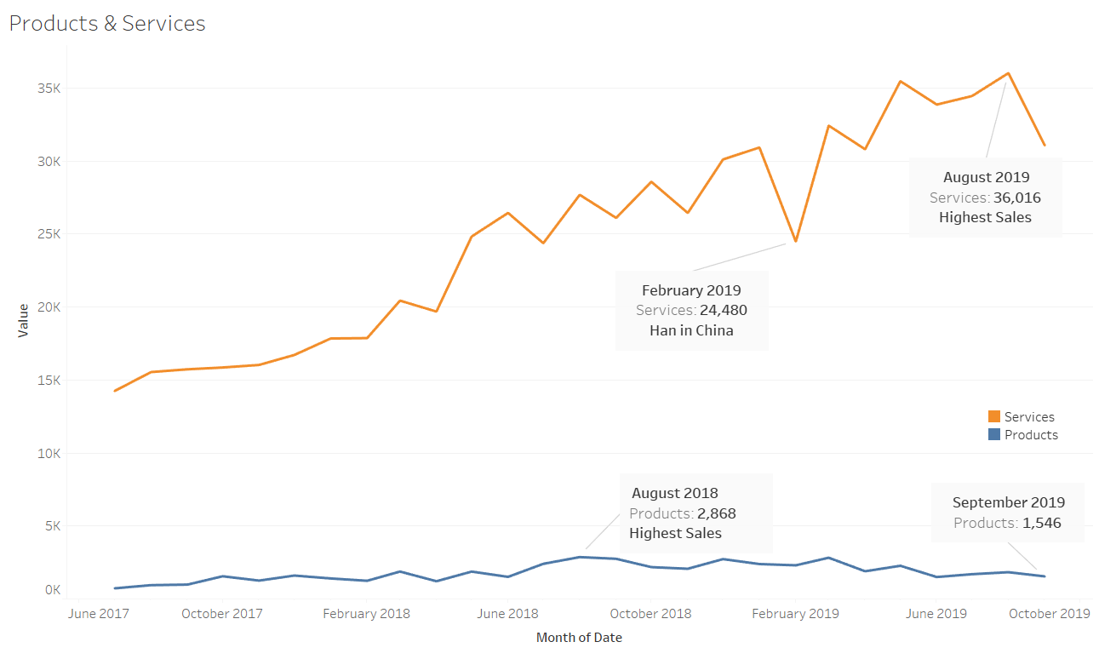

Graphic shows net total sales with scale comparisons of retail versus service revenue. Clearly service sales should always be top priority. Even at this scale the slow decline of retail sales is evident. Key peaks and valley highlighted.

## Figure 2 – Monthly Sales Breakdown

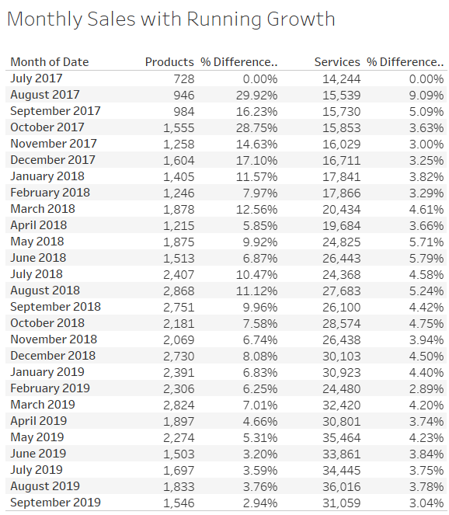

%Difference = running monthly growth rate pegged to the first datapoint.

## Figure 3 – Service Sales by Stylist

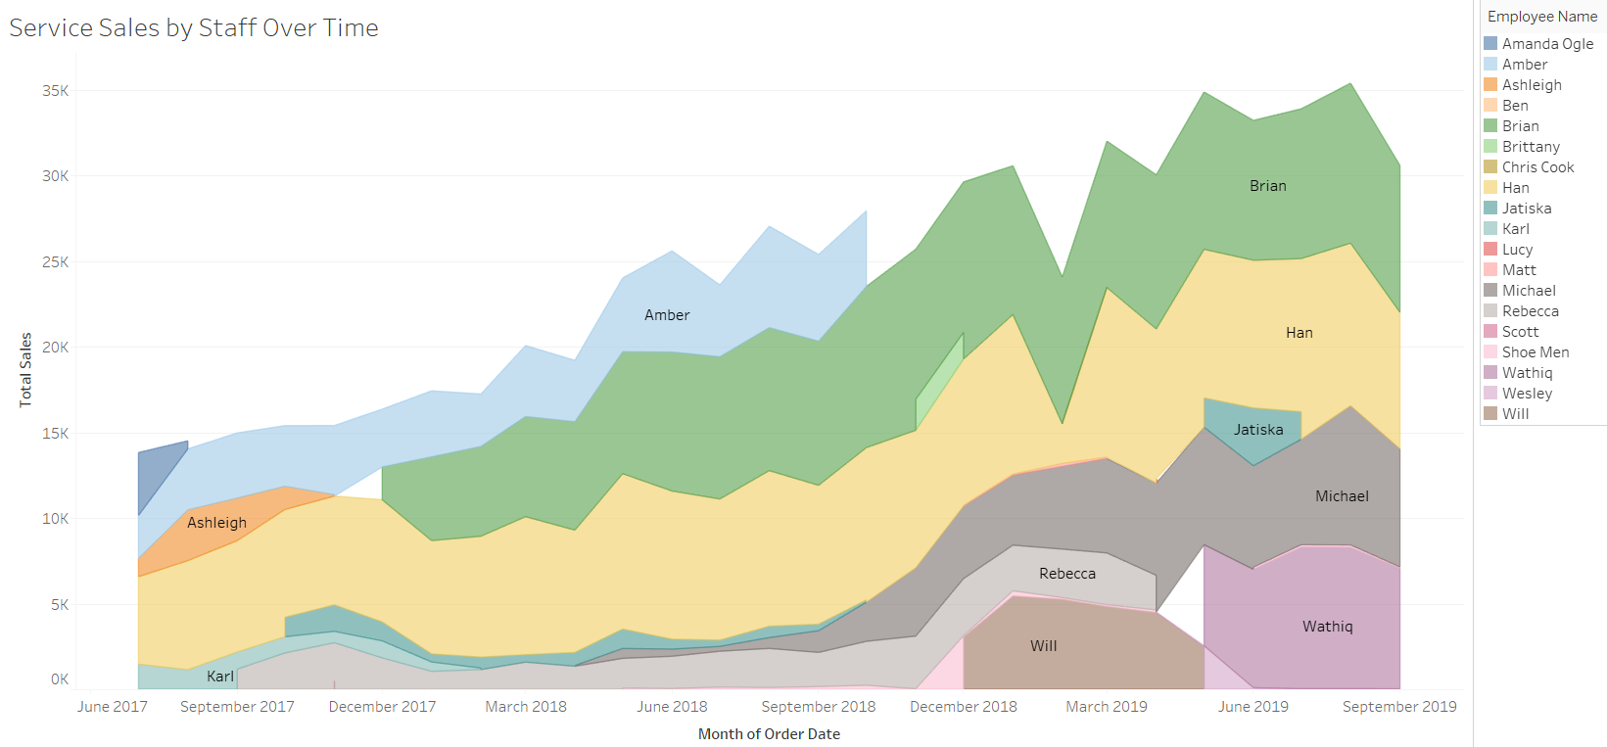

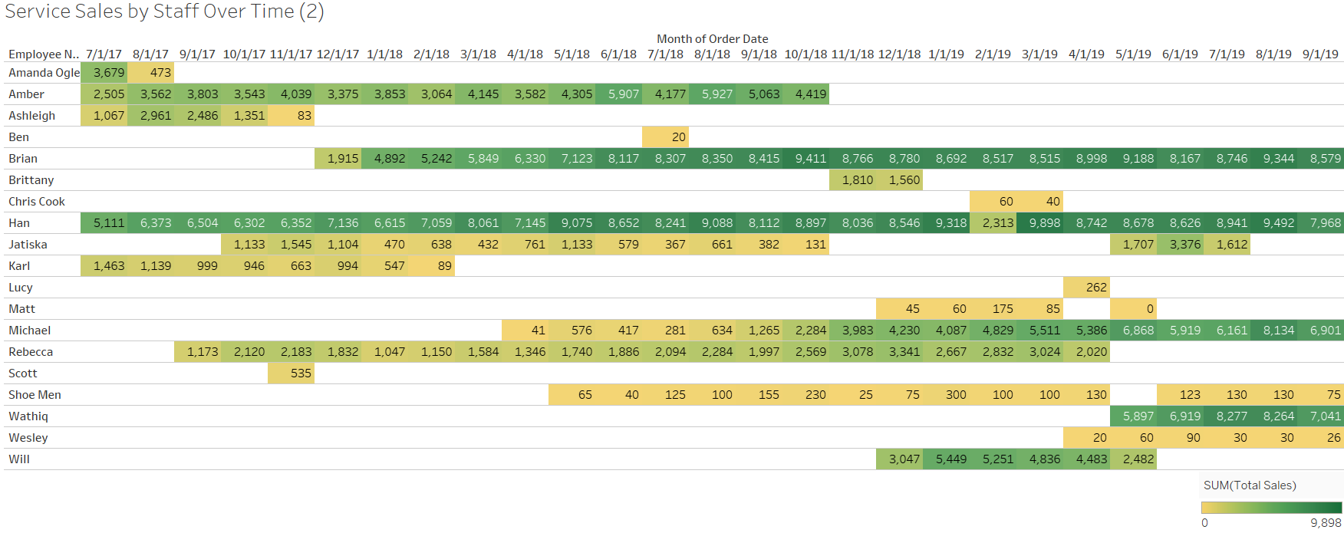

Graph and table tells the story of each stylist’s service revenue. The top line is effectively total net service revenue. A clear upward trajectory of service revenue is apparent across the 27 month dataset. The graph also shows near even revenue contributions from each of the four full-time stylists by September ’19. Also encouraging, three of four stylists have about 2 years of tenure or more with Ironworks indicating low turnover. Each stylist contributes roughly the same revenue each month.

## Figure 4 – Product Sales: Past 12 Months

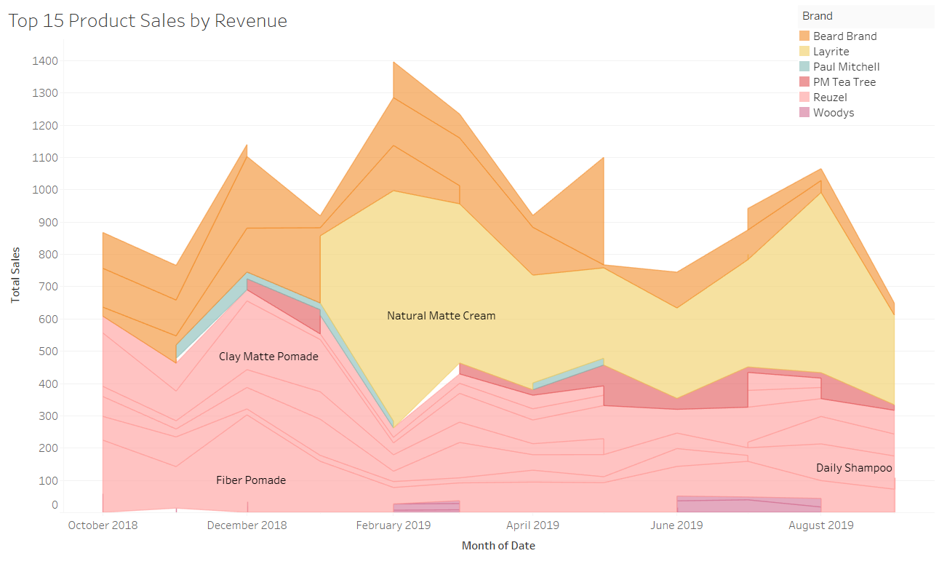

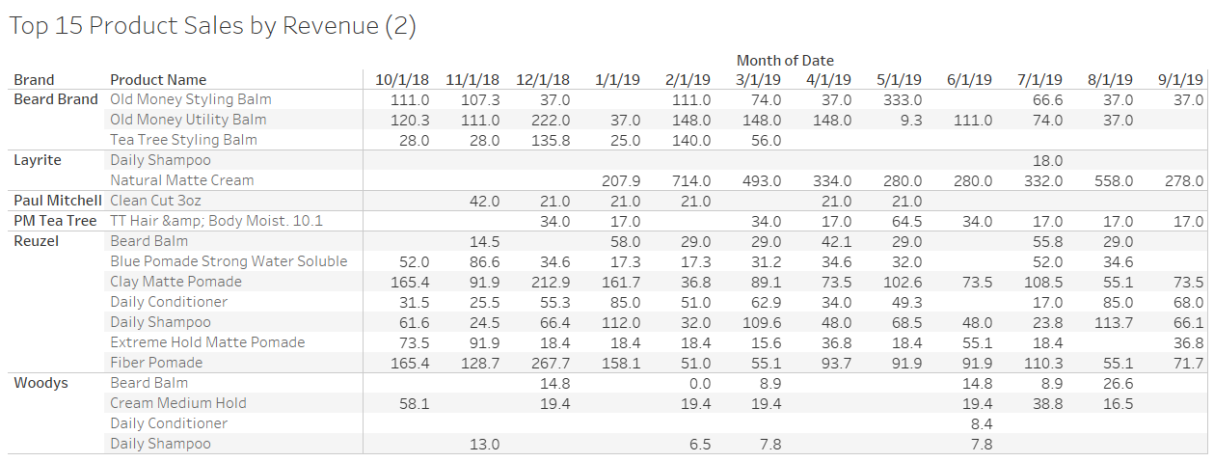

High-end hair care may be just as affected bytrends in the market as many other high-end personal items such as clothing and accessories. The short lifecycle of each brand is evident in the data. Items tend to sell well at first and then slowly reduce. Note that this is a short dataset so it is unclear if sales are cyclical or periodic.

## Figure 5 – Cigar Sales

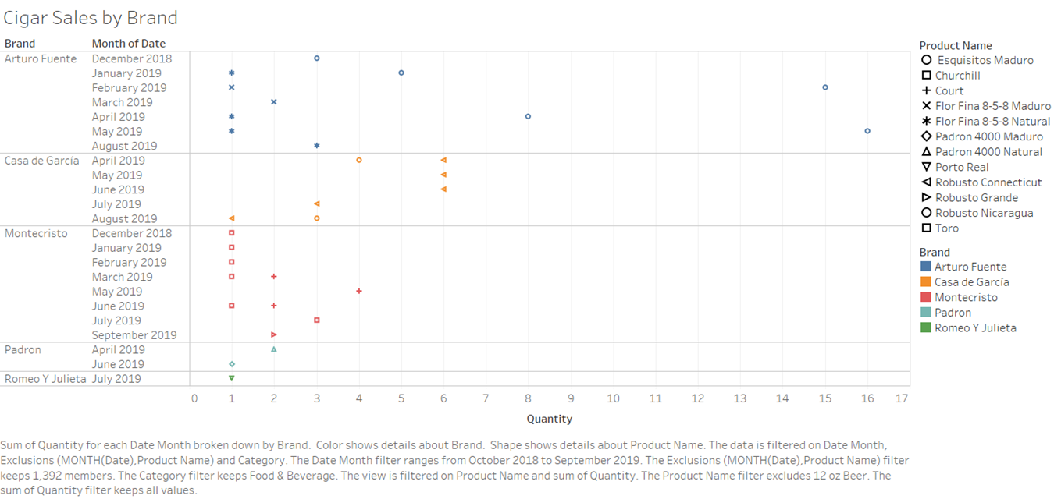

The historical sales are spotty and the dataset is too short (on cigars) to draw conclusions but there is certainly potential for growth in this category. Unit sales high but revenue contribution is modest.

## Figure 6 – Retail Sales by Category, since June 2017

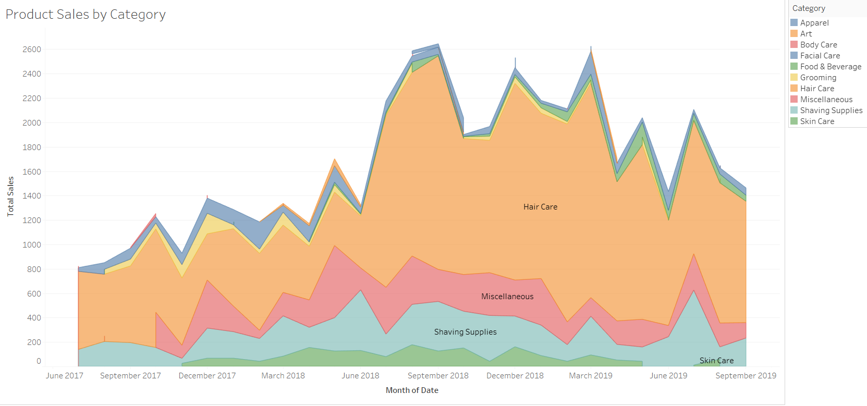

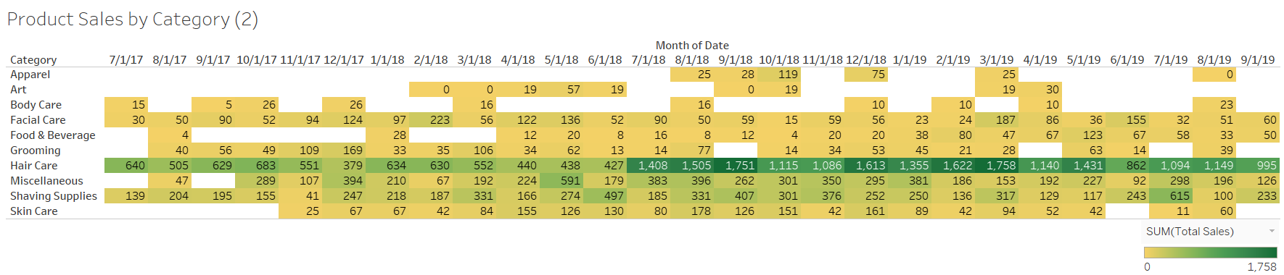

Graph shows majority of retail revenue contributions from hair care products. Retail sales reflect core business. Much like the service revenue graph, the top line is effectively the total net retail revenue. Different from the service side, retail sales peak in mid/late ’18 and slowly declined to present.

## Figure 7 – Top 15 Retail Sales, 2019

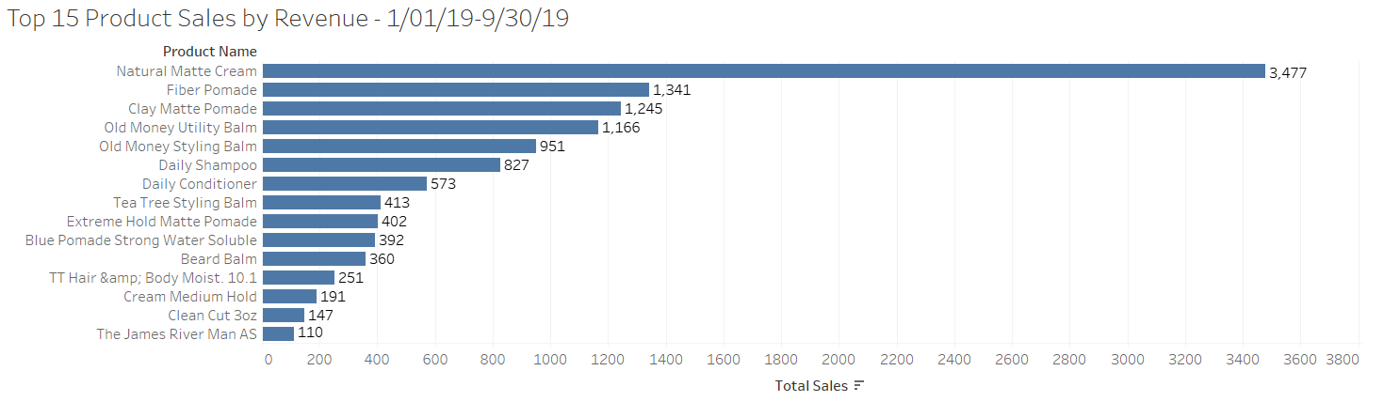

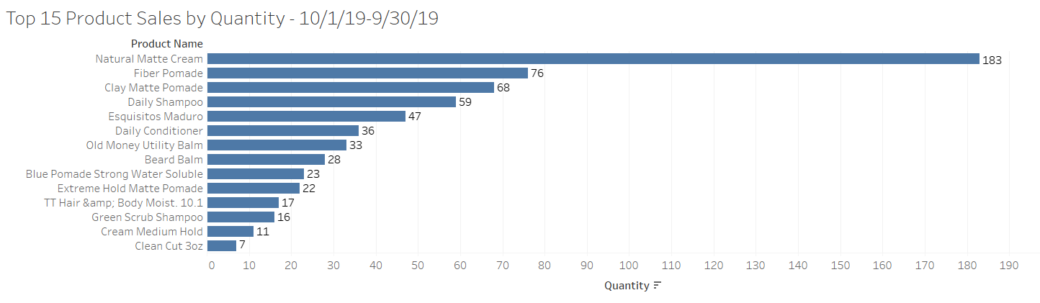

Pomades top the list by both measures. Esquisitos Maduros makes the list by quantity which is encouraging for cigar sales.

## Figure 8 – SWOT Analysis Matrix

|  |  |  |
| --- | --- | --- |
|  | Strengths  Differentiated Service,  Brand, Retail Sales | Weaknesses  Low Capacity,  Sales Technique |
| Opportunities  Social Media Presence  Expansion | Drive future expansion by leveraging strong service reputation, brand and retail sales through more frequent social media content. | Use social media to increase retail merchandise sales and promote service during off-peak times. Counter low capacity and increase sales by expanding through store buildout or expansion. |
| Threats  Competition  Local Market Forces | Maintain high standards, do not dilute brand to resist threat of competition from lookalike salons. In doing so, be conscious of local economic climate and trends. | Keeping the business small and lean may provide consistent profits and business agility. However, carefully executed sales techniques will provide consistency and differentiated retail service. |

A detailed breakdown of topics is discussed in body of report. The SWOT matrix is a visual representation of how to leverage internal strengths and weaknesses against external opportunities and threats.

1. Oliver, “Hair Salons in the US.”
2. Fernandez, “Barber Shops in the US.”
3. Ibid.
4. Ibid.
5. Ibid. Oliver, “Hair Salons in the US.”
6. Ibid.
7. Ibid. Fernandez, “Barber Shops in the US.”
8. Bureau, “2019 National and State Population Estimates.”
9. Ibid. Fernandez
10. Yelp, “THE BEST 10 Men’s Hair Salons in Richmond, VA”
11. “Barber Shops.” Industry Market Report - Zip Codes: 23059, 23060 & 23233
12. Ibid. Yelp
13. Ibid. Fernandez
14. “Median Age of the U.S. Population 1960-2018.”
15. “U.S. Household Income Distribution.”
16. Fernandez, “Barber Shops in the US.”
17. Oliver, “Hair Salons in the US.”
18. Ibid.
19. “The 8-Step Process for Leading Change | Dr. John Kotter.”